In English this half term w we will

**Geography**

This half term, the children will be learning about the Amazon Rainforest. They will learn about deforestation and other threats to the environment as well as about the physical features and the indigenous people that live there.

**English**

In English this half term we will be reading two texts. The Explorer and a non-fiction text about The Amazon. The children will have lots of opportunities to write about these texts. They will also be learning different grammar, punctuation and spelling rules.

**Ashfield Valley Primary School**

**Year 6 - Autumn Newsletter 1 -2023**



Dear parents/guardians,

We would like to extend a warm welcome to your child. It will be a very busy half term as we have a lot to do, but we hope it will be a lot of fun!

P.E. is on Monday so your child will need the correct kit in school on that day. They will bring it home the same day.

Please ensure that your child reads regularly and takes time to study the knowledge organisers for Geography Science and Maths.

The children will be bringing a spelling book home with their own list of spellings to learn. They will be tested on their spellings every week and then given a new spelling list to learn.

It is vital that your child continues to practise times tables and associated division facts regularly.

Many thanks,

Mrs Noor and Mrs McGrath

**Mathematics**

Your child will be learning place value up to ten million. They will also complete written methods for addition, subtraction, multiplication and division. We will be completing lots of times tables work so please help your child by testing them regularly.

**D.T**

In Design Technology the children will be learning about bird hides. They will research, design and make their own bird hides using a range of materials.

**You might like to take a trip to Hollingworth Lake or Pennington Flash to look at the bird hides and enjoy a family day out!**



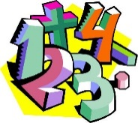

**Science**

This half term the children will be exploring the question- ‘What are the functions of the circulatory and nervous systems?’ They will learn about how exercise can affect our bodies and about the functions of the heart and lungs.



**Religious Education/RHE**

In RE the children will be learning about what religions say to us when life gets hard.

In RHE the children will discuss their strengths and set goals for the future.

out about the church. They will find out what is inside a church and what it is used for. They will find out about the people who go to church and the people who work in it.`1

**Computing**

The children will be learning to stay safe online and also about blogging.

We will discuss the age requirements for video games and social media.

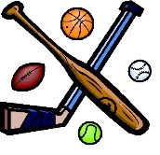

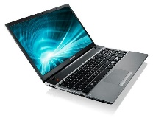

**Physical Education**

This half term the children will be developing their netball skills in PE.