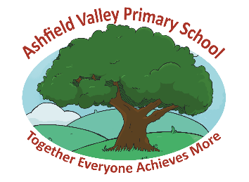

Use of RAAC in school

Dear Parents and Carers,

You may have seen recent media coverage regarding Reinforced Autoclaved Aerated Concrete (RAAC) and its use in educational settings. RAAC is a lightweight form of concrete; because it is weaker than regular concrete, concerns have been raised about its long-term durability. The Department for Education (DfE) has recently changed its guidance to education settings on the management of RAAC to take a more precautionary approach and as a result areas in affected spaces will be vacated.

We wanted to inform you that we are not affected by this decision as we do not have RAAC in any of our buildings and therefore they will continue to function as normal. We understand that parents may want to understand more about the support to educational settings to manage RAAC safely. You can read more through the article published by the DfE on the Education Hub.
I hope that this offers reassurance.
Please do contact me if you have any questions regarding this matter.
Yours sincerely,
Mrs H Edge
Headteacher

